FSH Society: Celebrity PSA Outreach Toolkit
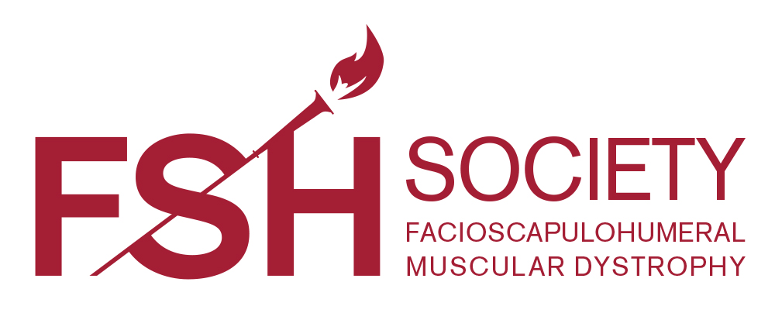

Dear FSH Society Volunteer,

Thank you for helping the FSH Society in our mission to spread awareness about FSHD by helping to promote our public service announcements (PSAs).

This packet is designed to help you in your communications with your local TV stations’ Public Service Directors.

If you have additional questions or concerns, please do not hesitate to contact us at any time.

Sincerely,

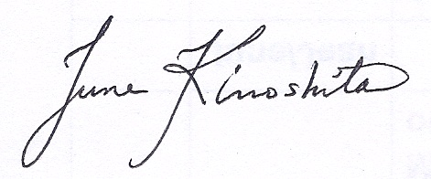

June Kinoshita
Executive Director
FSH Society
450 Bedford Street
Lexington, MA 02420
Phone: 781-301-6649
E-mail: june.kinoshita@fshsociety.org

Facioscapulohumeral Muscular Dystrophy (FSHD) Fact Sheet

What is FSHD?
- FSHD is one of the most prevalent of the nine primary types of muscular dystrophy affecting adults and children.

  - It affects approximately 1 in 8,000 people around the world, or over 870,000 worldwide. The actual frequency may be three times higher due to undiagnosed cases.

What are the symptoms?
    - FSHD causes a progressive loss of any skeletal muscle. Weakness is usually noticeable starting with facial, scapular/back, upper arm muscles, trunk and lower legs.

- Weakness in facial muscles is a hallmark of FSHD – early symptoms can include difficulty whistling or smiling and eyes not fully closing during sleep.

- Loss of muscular strength limits both personal and occupational activities. 95% of patients develop noticeable muscle weakness by the age of 20. Approximately 20% of patients become unable to walk.

- Respiratory insufficiency, which can be life-threatening, is also a symptom.

Who is affected?
      - FSHD occurs with equal frequency in both males and females and can affect children and adults of all ages and all racial groups.

  - An affected parent has a 50% chance of passing the genetic defect to each child. The majority of cases of FSHD are caused by a genetic deletion on chromosome 4.

      - The age of onset is variable, as is the eventual extent and degree of muscle loss.
      - Every person has the DUX4 gene that leads to FSHD. Usually, the gene is “bottled up” so it can’t cause harm, but when the bottle “breaks”, FSHD results.

- 30% of new FSHD patients have no prior family history and are a result of a spontaneous genetic change. In this sense, every person has a risk of having a child with FSHD.

What are the Treatments?
- Currently, there is no treatment to slow down or cure FSHD.

- Low-intensity aerobic exercise appears to be safe and potentially beneficial. This should be done under the supervision of a physical therapist.

- Genetic diagnostic and prenatal diagnostic tests are available for FSHD.
- Researchers hope to develop new drugs for FSHD over the next 3-5 years. There is hope!

News Alert for PSA Outreach

Broadcast FSH Society Celebrity TV PSAs and Educate Your Audience about FSH Muscular Dystrophy

PSAs feature Broadway Star Kelli O’Hara and “Glee” Star Max Adler

FSHD, one of the most prevalent types of muscular dystrophy, is a degenerative muscle disease that causes progressive weakness, usually starting with the face, shoulder and arms, but which can attack almost any skeletal muscle. FSHD affects approximately 870,000 people worldwide and between one and two percent of the population carries a genetic trait that places future generations at risk of the disease. Currently, there is no treatment or cure.


The FSH Society is a world leader in combating muscular dystrophy. The non-profit has provided millions of dollars in seed grants to pioneering research worldwide, creating an international collaborative network of patients and researchers. The FSH Society seeks to serve as a source of information and support for all patients and families with FSHD; act as a driving force in the development of research directed towards treatments and ultimately a cure; and bring support to patients and research for FSHD through effective engagement of governmental and private sector organizations and entities.

Please help the FSH Society raise awareness about the most prevalent muscular dystrophy.

The FSH Society Celebrity TV PSA spots featuring 2015 Tony award-winning actress Kelli O’Hara and “Glee” star Max Adler, including our new “Facts” campaign with voiceover by him, are available in :30 and :60 versions. The PSA spots can be downloaded in broadcasting format at:
http://tvaccessspotsource.com/facioscapulohumeral-muscular-dystrophy-society

We encourage you to consider airing these PSAs because their message is important for your listeners and our local community. Many people and doctors do not recognize the symptoms of FSHD, leaving patients to suffer without knowing where to turn for help. The “Facts” PSA promotes our #CureFSHD campaign and refers viewers to the FSH Society, where they can find support, education and referrals that are critical to so many. Even more importantly, patients need to know about research breakthroughs and the promise of treatments soon.

Thank you for your consideration of airing the FSH Society PSA. You can bring a message of hope and help to thousands of patients and families in your community.

Who: The FSH Society

What: FSH Society Celebrity and “Facts” PSAs staring Kelli O’Hara and Max Adler, available in :30 and :60 second TV spots

Affiliate Outreach Letter/Email Outline

Dear Public Service Director,

I am writing to you regarding five public service announcements about the FSH Society featuring 2015 Tony Award-winning actress Kelli O’Hara and “Glee” star Max Adler. I want to encourage you to air these very important messages about the most prevalent form of muscular dystrophy.

Information about the FSH Society and FSHD:

- FSHD is one of the most prevalent of the nine primary types of muscular dystrophy affecting adults and children.
- It is estimated to affect 870,000 around the world; the actual frequency may be three times higher due to undiagnosed cases.
- 95% of patients develop noticeable muscle weakness by the age of 20.
- Currently, there is no cure for FSHD.
- The FSH Society is a world leader in combating muscular dystrophy.
- Patients can contact the FSH Society for much-needed information and support.
- The non-profit has provided millions of dollars in seed grants to research worldwide.
- The FSH Society has received Charity Navigator’s 4-star award every year since 2009.

We encourage you to consider airing these important PSAs because their message can be life-changing for your viewers and our local community. The PSAs refer viewers to the FSH Society website, where they can find patient support, educational materials and referrals that are critical to many people.

The PSA spots are available to preview on the FSH Society’s YouTube channel at:
Kelli O’Hara (60 secs) https://www.youtube.com/watch?v=owGQxJxYTW8
Kelli O’Hara (30 secs) https://www.youtube.com/watch?v=dBRn3wwx9R4
Max Adler (60 secs) https://www.youtube.com/watch?v=pOtsPrNhhEc
Max Adler (30 secs) https://www.youtube.com/watch?v=zvsMBCB8Qd4
Facts About FSHD (60 secs) https://www.youtube.com/watch?v=u1l_2h0Rmzk

They can be downloaded in broadcasting format at:
http://tvaccessspotsource.com/facioscapulohumeral-muscular-dystrophy-society

Will you be able to air one or more of the FSH Society PSAs? You can join us in bringing a message of hope and help to thousands of people in our community.

Thank you,

Name
Email
Phone number

Follow-up Phone Call Talking Points

These talking points are meant to guide you when contacting public service directors at your local TV station via phone. Follow up with the stations after you have mailed the PSA directly.

Introduction

I’m calling on behalf of the FSH Society regarding five celebrity PSAs that have been sent to you for review.

The PSAs feature Broadway star Kelli O’Hara and “Glee” actor Max Adler.

As a volunteer of the FSH Society, I encourage you to consider airing these PSAs. I believe their message is very important for your listeners and our community.

Ask:
- Have you viewed the PSAs?
- Do you plan to air the PSAs?
- If not, do you plan to?

If applicable, suggest a meeting with them or the station manager to share more about the FSH Society’s goals and how they are helping people across the country

Troubleshooting

If the PSA Director can’t find the PSA, offer to send the download link or a hardcopy.

If the station does not have a PSA Director, you should ask to speak with the Program Manager.

If they are not available, leave a voice mail message, identifying that you are a local leader calling about a PSA previously sent to them, and will call them back a second time.

Other helpful Talking points

Objection: “I just don’t have enough time for all the PSAs I receive.”
Response: Recognize the pressure the station is under concerning PSA time with so many valid issues from which to choose. We just want to remind them that FSHD is at a tipping point. Drug discovery is progressing rapidly, and this is a critically important time for people to seek help and get on lists for clinical trials, and of the public to join the push for cures and treatments to help more people who live with FSHD.

Objection: “This issue is not locally relevant.”
Response: Be prepared with facts. Taking someone who lives with FSHD with you to your presentation can also bring to life that this disease is an important local issue. If appropriate, mention the number of members in your area and the events that you hold every year.

Objection: “The issue does not match my station theme for this period.”
Response: Ask what the theme is. Acknowledge the difficult place you put the media gatekeeper in and assure them that the issue deserves the commitment of their station and its valuable airtime. Determine if our message can fit into an extended definition of their theme. If the objection still stands, ask when the policy is likely to change and when would be an appropriate time for the FSH Society to contact the station again.

Objection: “We need quality PSAs.”
Response: Point out that our PSA will break through the clutter because they are of extremely high quality, featuring acclaimed actors and created by the American Movie Company, a top production studio that works on many prime-time shows, and we think they will agree.

Thank You Letter Outline

Dear Public Service Director,

Recently, I contacted you regarding PSAs on behalf of the FSH Society starring Kelli O’Hara and Max Adler with an important message about FSHD, the most prevalent form of muscular dystrophy.

We want to thank you for airing the PSAs.

Some information about FSHD:

- FSHD is the most prevalent form of muscular dystrophy affecting adults and children.
- It is estimated to affect 1 in 8,000 people around the world. The actual frequency may be significantly times higher due to undiagnosed cases.
- 95% of patients develop noticeable muscle weakness by the age of 20.
- Currently, there is no cure for FSHD.
- Patients can find much-needed information and support at the FSH Society.

Again, we thank you for airing the PSAs as the message is so important for your viewers and our local community.

Sincerely,

Name
Email
Phone number

