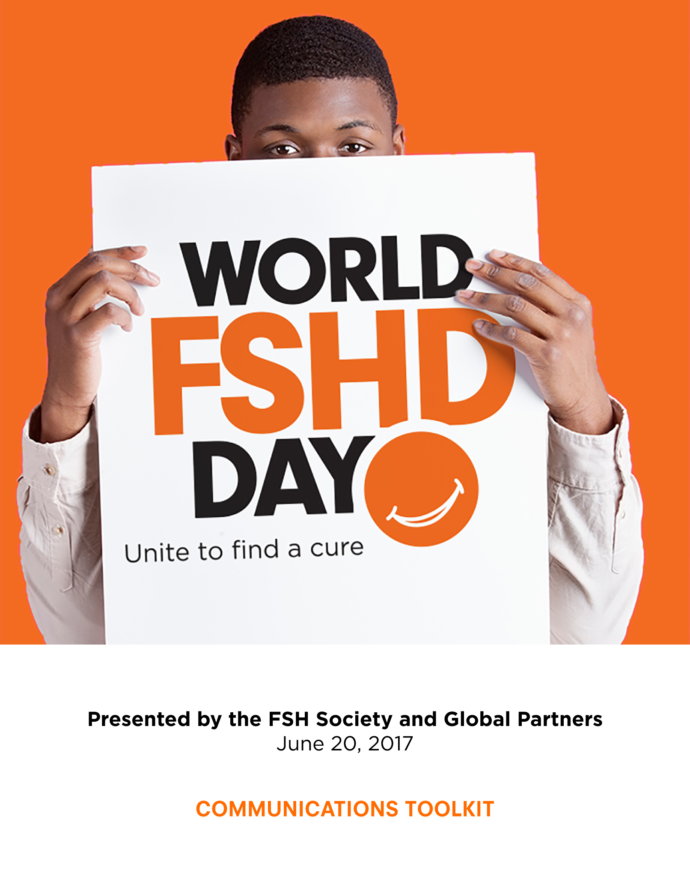
World FSHD Day Communications Toolkit

What is FSHD? 2

Facts & Statistics 3

What is World FSHD Day? 4

World FSHD Day Logos 5

Local World FSHD Day Event Media Alert 6
Campaign: Orange Slice Selfies 7
- Media Pitch Template
- Social Media Promotion

Campaign: Light the Night Orange 8-9
- Letter to Your Local Officials
- Media Pitch Template
- Social Media Promotion

What is FSHD?

Symptoms of facioscapulohumeral muscular dystrophy

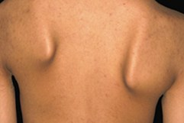
A common first sign of FSHD, asymptomatic scapular winging and difficulty reaching above the shoulder level.

Facioscapulohumeral muscular dystrophy (FSHD) is broadly characterized as a neuromuscular disease (NMD), as are all types of muscular dystrophy. Muscular dystrophies are marked by progressive skeletal muscle weakness, defects in the biochemical, physical, and structural components of muscle, and the death of muscle cells and tissue. FSHD gets its name because the progressive loss of skeletal muscle is usually noticeable across facial (facio), back (scapula), and upper arm (humeral) muscles. The core, hip girdle, and legs can also be affected in many patients. Muscle weakness often sets in asymmetrically, affecting only one arm or one leg, for example, and as a result may be mistakenly attributed to strain or a sports injury.

Symptoms may manifest early, sometimes years before a formal diagnosis. These can (but don’t always) include:

- Inability to smile;
- Inability to whistle;
- Inability to sip through a straw;
- Eyes that don’t close fully during sleep;
- Difficulty with such exercises as sit-ups and pull-ups;
- Shoulder blades that “wing” out;
- Difficulty raising arm above shoulder height;
- Foot drop (foot dorsiflexion weakness);
- Weak lower abdominal muscles, protuberant abdomen;
- Curved spine (lordosis).

Patients can also experience:
- Episodes of “malaise” or “burning pain” in muscles;
- Severe pain from changes in posture and strain on remaining muscles;
- Chronic fatigue;
- Respiratory insufficiency;
- Hearing loss;
- Coats’ disease (retinal telangiectasis).

Additional information:
- Download a brochure About FSHD
- Download a Physical Therapy and FSHD brochure
- Diagnosis
- Genetic testing
- Infantile FSHD

Facts and Statistics

Facioscapulohumeral (fā-sh(ē-)ō-ˌskap-yə-lō-ˈhyüm-(ə-)rəl)
FSHD gets its name because of the type of progressive loss of all skeletal muscle, where weakness is usually noticeable across facial (facio), back (scapula), and upper arm (humeral) muscles.
FSHD is the most prevalent of the nine primary types of muscular dystrophy affecting adults and children. It is a genetic disorder. Previously, studies estimated the prevalence at around 1 in 20,000 people, but a 2014 Dutch study reported a much higher prevalence of 1 in 8,333.
Estimated to affect about 870,000 individuals worldwide, the actual number of individuals with FSHD could be significantly higher due to undiagnosed cases.
FSHD is worldwide in distribution, affects both sexes equally, and has no particular racial, geographic, or ethnic distribution.
The age of onset can range from infancy to adulthood. The eventual extent and degree of muscle loss is also highly variable. The prognosis for FSHD includes a loss of muscular strength that limits both personal and occupational activities, and approximately one-quarter of patients over 50 years of age require the use of a wheelchair.
Although the progression of FSHD is quite variable, it is usually relatively slow, with most patients developing noticeable muscle weakness by the age of 20 in males, and by the age of 30 in females.
Thirty percent of new FSHD patients have no prior family history of the disease and are a result of congenital spontaneous genetic mutation. Once present, however, FSHD is genetically transmissible in an autosomal dominant fashion. This means that an affected parent has a 50 percent chance of passing the genetic defect on to each child.
Approximately 95 percent of FSHD cases are known as Type 1 (chromosome 4-linked FSHD; also called FSHD1 or Type 1A). FSHD1 is linked to deletions of D4Z4 units on chromosome 4.
The remaining 5 percent of FSHD cases have normal-length D4Z4 regions on chromosome 4 and are called Type 2 (FSHD2, also called Type 1B). A majority of FSHD2 has now been linked to mutations on a gene called SMCHD1, on chromosome 18. There are still ~1% of FSHD cases of unknown genetic cause.
Both FSHD1 and FSHD2 have similar symptoms. Even though the genetic causes are distinct, both types appear to have the same end result at the molecular level: they cause the D4Z4 region to have less-than-normal levels of methylation, which allows the DUX4 gene to get expressed. So in spite of different genetics, FSHD1 and FSHD2 appear to be the same disease.

What is World FSHD Day?

World FSHD Day
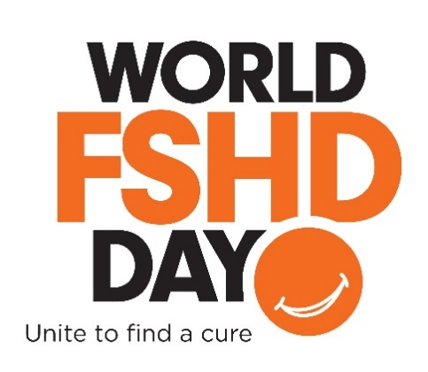
Every June 20, we gather to celebrate World FSHD Day to raise awareness for Facioscapulohumeral muscular dystrophy (FSHD). Participants from across the globe, advocacy organizations, including individuals with FSHD, as well as their families and supporters, come together in various ways to raise awareness for FSHD, one of the most prevalent forms of muscular dystrophy.

The FSH Society and fellow members of FSHD Champions, the international alliance of FSHD advocacy organizations, look to recognize individuals with FSHD, their families, physicians, researchers and supporters with various local activities, sharing the official logo, and patient stories.

In 2017, the FSH Society will be embarking on a social media campaign, our Orange Slice Selfies campaign. Supporters are encouraged to share selfies using orange slices in place of their smiles, using #WorldFSHDDay.

In addition, we encourage supporters to reach out to their local Department of Public Works to light up notable landmarks orange in honor of patients and families. For more information and tips on how to present this ask to your local officials, please continue reading this toolkit.

To learn more about World FSHD Day or to find an event near you, visit the FSH Society’s World FSHD Day Facebook event page. To assist in promoting your own event as part of World FSHD Day, please continue reading through this toolkit.

World FSHD Logos

Official Logos

JPEG:
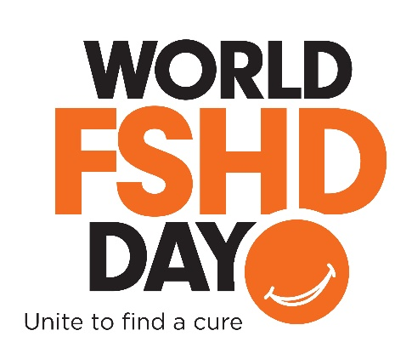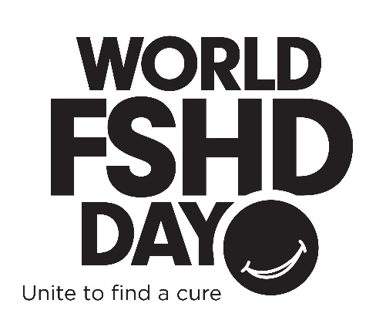

PNG:
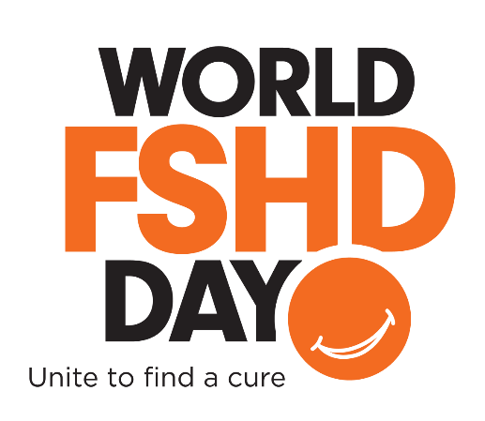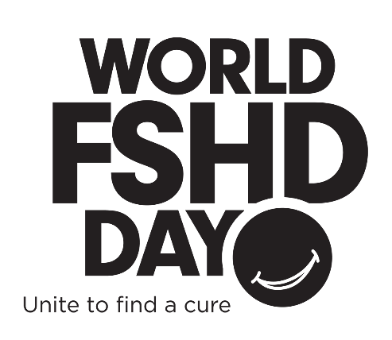

Local Event Media Alert

[GROUP] to Host [EVENT] Celebrating Second Annual World FSHD Day
[DATE AND LOCATION]

WHAT: On [DATE], join [ORGANIZATION] at the [EVENT NAME] in [LOCATION] to celebrate the second annual World FSHD Day to raise awareness and recognize global progress being made towards finding a cure for Facioscapulohumeral Muscular Dystrophy (FSHD). [EVENT] is a local fundraiser in support of the FSH Society in celebration of World FSHD Day on June 20, 2017. Photo opportunities will also be made available.
Families, friends and supporters are welcome, and all net proceeds benefit the FSH Society, an award-winning non-profit and global leader in the quest to treat and cure FSHD. To donate online to the FSH Society in support of World FSHD Day, please visit www.fshsociety.org.

WHEN: DAY, MONTH XX from TIME to TIME am/pm.

WHERE: NAME OF LOCATION
ADDRESS OF LOCATION

WHY: 2017 marks the second annual World FSHD Day through activities by patients, researchers and organizations uniting to educate the public and advocate for research to find a cure. Facioscapulohumeral muscular dystrophy, FSHD, is a genetic disorder that progressively leads to the weakening of skeletal muscles, and may render the inability to smile, or whistle. Typically beginning in teenage years with the loss of muscles in the face (facio), shoulders (scapula), upper arms (humerus), legs or core. FSHD can spread to any muscle and there is no cure. It is the most prevalent form of muscular dystrophy, affecting more than 870,000 worldwide. To learn more, visit the non-profit FSH Society at www.fshsociety.org.

Contact: [LOCAL ORGANIZER ONSITE CONTACT INFORMATION]
FIRST NAME, LAST NAME
EMAIL
PHONE

About the FSH Society: The FSH Society is a world leader in combating FSH muscular dystrophy, a genetic disorder that progressively leads to the weakening of skeletal muscles, and may render the inability to smile, or whistle. The non-profit has provided millions of dollars in seed grants to pioneering research worldwide, creating an international collaborative network of patients and researchers. The FSH Society seeks to serve as a source of information and support for all patients and families with FSHD; act as a driving force in the development of research directed towards treatments. For nine consecutive years, the Society has received the Charity Navigator’s four-star rating, the highest distinction held by less than two percent of non-profit organizations in the country. For more information visit http://www.fshsociety.org or call (781)-301-6649.
# # #
Campaign: Orange Slice Selfies

Media Pitch

Subject: Wear your Orange Slice Selfie to Celebrate World FSHD Day
Hi X,

On June 20, residents of [TOWN] will be posting selfies with orange slices as smiles via social media in celebration of World FSHD Day, and to honor patients and families who suffer from FSH muscular dystrophy.

2017 marks the second annual World FSHD Day through activities by patients, researchers and organizations uniting to educate the public and advocate for research to find a cure. With orange as the official color of World FSHD Day, please consider posting your own Orange Slice Selfies on June 20th with the official hashtag, #WorldFSHDDay and tagging the non-profit committed to finding a cure the, FSH Society, on Twitter, Facebook and Instagram.

Facioscapulohumeral muscular dystrophy, FSHD, is a genetic disorder that progressively leads to the weakening of skeletal muscles, and may render the inability to smile, or whistle. Typically beginning in teenage years with the loss of muscles in the face (facio), shoulders (scapula), upper arms (humerus), legs or core. FSHD can spread to any muscle and there is no cure. It is the most prevalent form of muscular dystrophy, affecting more than 870,000 worldwide. To learn more, visit the non-profit FSH Society at www.fshsociety.org.

Attached, please find a few orange slice selfies of my family and friends.

Thanks,
XX

Social Media Posts

Facebook Suggestions
- Mark your calendars, June 20, 2017 is World FSHD Day! The day serves to gather individuals with FSHD, their families and supporters, and members of international chapters. To learn more, check out https://www.fshsociety.org/
- On June 20, I’m raising awareness for World FSHD Day by sharing an Orange Slice Selfie! Share a photo of your Orange Slice Selfie to show your support.
- Today is World FSHD Day! To unite our community and raise physician awareness to help better diagnose and treat symptoms, share a photo of your Orange Slice Selfie and tag the FSH Society!
Twitter Suggestions
- Mark your calendars, 6/20 is #WorldFSHDDay to unite all those with #FSHD across the globe!
- I’m wearing my Orange Slice Selfie to raise awareness of #WorldFSHDDay on 6/20! Share your smile w @FSHSociety
- Did you know #FSHD affects 870K people worldwide? I’m sharing my Orange Slice Selfie on 6/20 to raise awareness for #WorldFSHDDay!
- Today is #WorldFSHDDay! Put on your Orange Slice Selfie to celebrate!
- It’s #WorldFSHD Day! To learn more about #FSHD visit https://www.fshsociety.org/

Campaign: Light the Night Orange

Letter to Your Local Department of Public Works

Date
Address of local public works office

Dear X,

My name is NAME and I serve as TITLE/MEMBER of the Boston-based FSH Society. I am writing to ask for a very special favor—to light up BUILDING this June 20th in honor of patients and families around the world who suffer from FSH muscular dystrophy.

This year, we will be celebrating the second annual World FSHD Day through activities with patients, researchers, and organizations worldwide uniting to educate the public and advocate for research to find a cure. We would greatly appreciate 2017 World FSHD Day to serve as an opportunity to spread awareness of FSHD, especially in CITY, and to that end, we would like to ask you to kindly arrange for the BUILDING to be lit up on the night of June 20th a bright orange, the official color for World FSHD Day

If you can accommodate our request, we will promote it through a world-wide social media campaign, sharing images of BUILDING in the World FSHD colors over Facebook, Twitter, and Instagram. Over a dozen biotech and pharma companies in the country are working on treatments for FSHD, and we will reach out to them in advance to enlist their help in spreading the message. This would be an incredibly powerful way to rally our community, with the BUILDING giving visibility on a scale that the FSHD community has never had before.

The FSH Society is the world’s leading nonprofit organization advocating for treatments for facioscapulohumeral muscular dystrophy. FSHD is the most common major form of muscular dystrophy, causing progressive muscle loss and disability. It affects almost a million people worldwide and there is no cure, but thanks to recent advances in research, we hope treatments will be developed soon.

For more information on the FSH Society, please visit https://www.fshsociety.org/. We hope that you will consider standing with FSHD patients across America, especially right here in CITY, by lighting the BUILDING orange in their honor this June 20th.

Respectfully,

Signature

Media Pitch

Subject: [BUILDING] lights up orange for World FSHD Day, 6/20
Hi X,

On June 20, the [BUILDING] will light up orange in celebration of World FSHD Day, and to honor patients and families in [CITY] and around the world who suffer from FSH muscular dystrophy.

2017 marks the second annual World FSHD Day. The celebration will include activities by patients, researchers, and organizations, uniting to educate the public and advocate for research to find a cure. With orange as the official color of World FSHD Day, please consider a shot of the orange [BUILDING] as coverage on June 20.

Facioscapulohumeral muscular dystrophy, FSHD, is a genetic disorder that progressively leads to the weakening of skeletal muscles, and may render the inability to smile, or whistle. FSHD typically beginning in teenage years with the loss of muscles in the face (facio), shoulders (scapula), upper arms (humerus), legs or core, and can spread to any muscle and there is no cure. It is the most prevalent form of muscular dystrophy, affecting more than 870,000 worldwide. To learn more, visit the non-profit FSH Society at www.fshsociety.org.

If interested in raising awareness of World FSHD Day, we’re also encouraging supporters to take an orange slice selfie and post on social media on June 20 with the official hashtag #WorldFSHDDay. If you do, please tag the FSH Society on Twitter, Facebook and Instagram.

Thanks,
XX

Social Media Posts

Facebook Suggestions
- Mark your calendars, June 20, 2017 is World FSHD Day! The day serves to gather individuals with FSHD, their families and supporters, and members of international FSH Society chapters. To learn more, check out https://www.fshsociety.org/
- On June 20, [CITY] is raising awareness for World FSHD Day by lighting [BUILDING] orange! Stop by at [TIME] to share a photo
- Today is World FSHD Day! To unite our community and raise awareness to help better diagnose and treat symptoms, the [BUILDING] is lighting orange for those with FSHD. Be sure to stop by [BUILDING] at [TIME] to share a photo with the official hashtag #WorldFSHDDay
Twitter Suggestions
- Mark your calendars, 6/20 is #WorldFSHDDay to unite all those with #FSHD across the globe!
- [BUILDING] will be lighting up orange to raise awareness to #WorldFSHDDay on 6/20! Stop by & share a photo to show support
- DYK: #FSHD affects 870K people worldwide? [BUILDING] will be lighting the sky orange on 6/20 to raise awareness for #WorldFSHDDay!
- Today is #WorldFSHDDay! The [BUILDING] will be lighting the night orange in celebration, be sure to stop by & share a photo!
- It’s #WorldFSHD Day! To learn more about #FSHD visit https://www.fshsociety.org/

