Instructions for World FSHD Day team fundraising

- Register your team. Contact Kate Puzzanghera (Kathryn.puzzanghera@fshsociety.org or 781-301-7301) with your full name and team name (e.g. “Team Smith Family”).

- Email high-resolution photo (300 dpi) to Brian Luoma (brian@gizmoplans.com). The photo can be of yourself or any individual whom you wish to honor, and will be turned into a magnetic decal that will be displayed on the support van for Team FSHD Cycling.
- Reach out to your friends and family and encourage them to support you in this fundraiser. See attached letter/social media templates. IMPORTANT: Please include this language on any letters/publicity: “Note: Team FSHD Cycling is holding its 2017 Race Across America Campaign as independent volunteers, not as employees, agents, Board members, advisors, or volunteers of the FSH Society.”

- Your friends can donate to the Society in the following ways:
  - Donate online here: http://bit.ly/TeamFSHD. It’s important that they make their donation as a tribute gift naming the honoree.
  - Mail a check to the FSH Society at 450 Bedford Street, Lexington, MA, 02420. If they mail a check, it’s important that they include a note saying who the gift is for. For example: “This donation is in honor of Team Emily Jones.” This information is important so that we can track your team’s progress!
  - You can collect checks and send them to the Society. Please be sure to provide us with your donors’ names and addresses so we can thank them!
- At the end of the challenge, The FSH Society will send you a report to let you know how much you raised in total, along with names of your donors so you can thank them. Your photo will be made into a magnet decal for the support vans that will ride across America with Team FSHD Cycling!

Questions? Please contact Kathryn.puzzanghera@fshsociety.org or 781-301-7301.

Important dates
Immediately: Donations begin getting counted towards this campaign
Thursday, June 7th: Last day for your donations to be counted!
Friday, June 8th: We will notify you of how much you raised in total and what you have won
Saturday, June 17th: Team FSHD Cycling embarks on Race Across America!
Tuesday, June 20th: World FSHD Day

All participants will receive recognition on the FSH Society website, FSH Watch Newsletter, and social media channels

Fundraising Milestones
Any donation up to $499: Get a 3”x3” photo decal of your honoree on the van
Raise $500: Get a 6”x6” photo decal of your honoree on the van
Raise $1,000: Get an 8”x8” photo decal of your honoree on the van
Raise $2,500: Get a 10”x10” photo decal of your honoree on the van
Raise $5,000: Get a 12”x12” photo decal of your honoree on the van
Raise $10,000: Get a 16”x16” photo decal plus a guest spot on FSH Society Talk Radio
PERSONALIZE THIS LETTER TO SEND TO YOUR FRIENDS:

Dear ________,

This year [MY FAMILY AND I] will be raising money to mark World FSHD Day, June 20th, and support the FSH Society’s work to fight FSH muscular dystrophy. This cause is very important to me and my family because… [YOUR PERSONAL CONNECTION TO FSHD, YOUR CONNECTION TO THE SOCIETY, HOW THIS DISEASE HAS AFFECTED YOU OR SOMEONE YOU LOVE.]

George Pollock, an FSH muscular dystrophy patient, has recruited the eight-person Team FSHD Cycling to compete in the Open Relay Division of the internationally renowned bicycle Race Across America. They expect to complete the 3,000-mile race in seven days starting in Oceanside, California, and ending in Annapolis, Maryland, to support the FSH Society.

Team FSHD Cycling is racing for [ME, MY FAMILY, MY FRIEND _____] and [I/WE] want to do our part to help find a treatment and raise awareness. Our goal is to raise [$$ GOAL AMOUNT]. If we reach this goal, [MY/OUR FAMILY’S/_____’S] photo will be displayed on the Team FSHD Cycling support van as it goes across America to raise awareness! We need to reach our goal by June 7th!

FSHD is a degenerative disease that affects nearly a million people worldwide, causing a progressive weakening and loss of skeletal muscles. The severity of the disease can vary greatly as some patients have minimal symptoms while others become wheelchair-bound. Triggered by an unusual genetic mechanism, FSHD affects both genders equally and has no particular racial, geographic, or ethnic distribution. Currently, there is no cure.

Many people are completely unaware of this disease, and the FSH Society and Team FSHD Cycling aim to change that. The Society is a world leader in combating FSHD and has helped raise millions of dollars to support scientific research and treatments. The FSH Society is a 501(c)(3) nonprofit tax-exempt organization. Donations made to the FSH Society are tax-deductible. The Society has earned Charity Navigator’s prestigious four-star rating for the ninth year in a row, achieving near perfect scores in fundraising efficiency, accountability, and transparency, a record that fewer than 1% of charities in the United States achieve.

Please consider supporting [YOUR TEAM NAME] by making a donation on the FSH Society website: http://bit.ly/TeamFSHD. Or you can mail a check to FSH Society, 450 Bedford Street, Lexington, MA, 02420. Remember to note on your donation that the gift is in honor of [HONOREE NAME/TEAM NAME]. I hope that you’ll stand with patients like [ME/MY FAMILY/_______] and support us in our fight as we Race Across America together.

Thank you!

[NAME]
[PHONE] [E-MAIL]

Disclaimer: Team FSHD Cycling is holding its 2017 Race Across America Campaign as independent volunteers, not as employees, agents, Board members, advisors, or volunteers of the FSH Society.

Sample Social Media Posts

For Facebook:
Help me do a great thing today! This June 20th is World FSHD Day, and I’m raising awareness and funds for FSH muscular dystrophy (FSHD), a disease that has affected me personally. I need to raise $___ by June 7. If I reach my goal, my photo [or my loved one’s photo] will be displayed on the support van for Team FSHD Cycling, which is competing in this year’s Race Across America (RAAM), an epic, 3,000-mile cycling event. Make your donation at the link below, and be sure to make it a tribute gift in honor of [YOUR TEAM NAME]. Donations to the FSH Society, a 501(c)(3) nonprofit organization, are tax deductible.

Thank you so much, and please share this with others. Together, we can get our stories out to the world, raise awareness, and help find treatments!

Note: Team FSHD Cycling is holding its 2017 Race Across America Campaign as independent volunteers, not as employees, agents, Board members, advisors, or volunteers of the FSH Society.

http://bit.ly/TeamFSHD

Optional: Post your honoree’s photo with your FB post.

For Twitter:

Donate to my cause! Raising $ and awareness for #WorldFSHDDay and @fshdcycling in honor of ____. http://bit.ly/TeamFSHD
[POST PHOTO]

Help us find treatments for FSH muscular dystrophy! #WorldFSHDDay and @fshdcycling in honor of ____. http://bit.ly/TeamFSHD
[POST PHOTO]

Use our logos on your social media posts to help spread awareness about your fundraising!

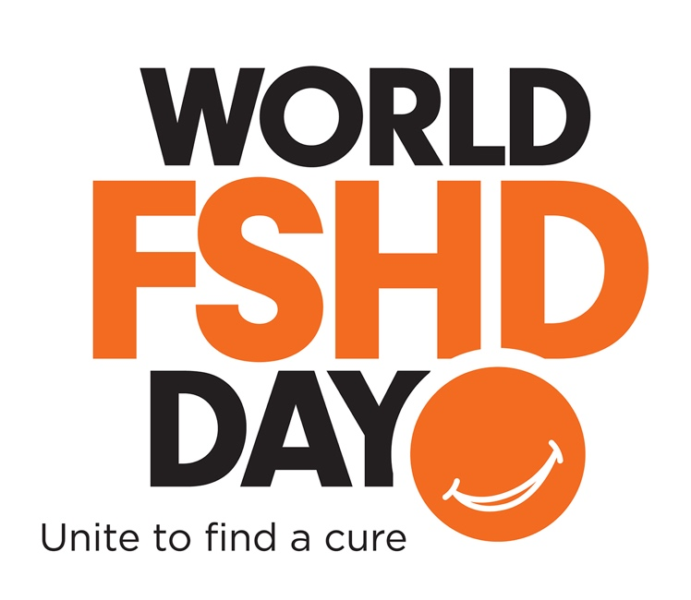

Team FSHD Cycling Official Image

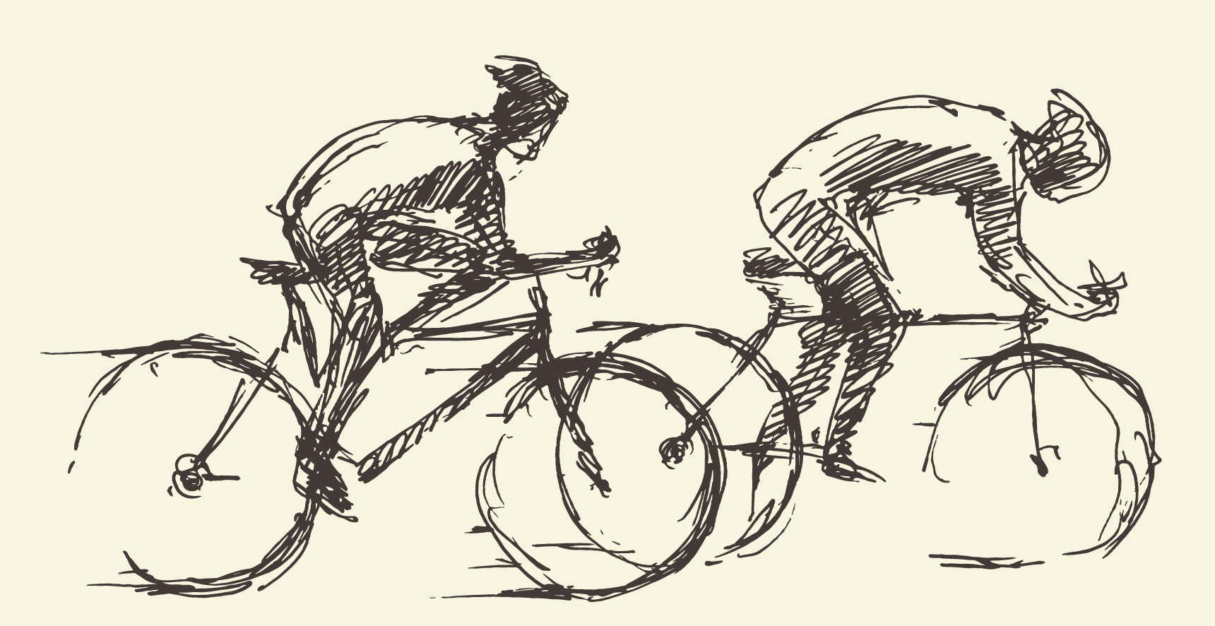

Here are some tips to help you have a successful fundraiser:

- Create your appeal letter (see the template provided in this toolkit as a guide).
- Ask anyone and everyone that you know to contribute, even if it's a very small amount.
- Don't be afraid to ask. It's not about you; it's about the research and greater cause for/of FSHD. Put any fear aside and think of the people this will impact.
- Focus on participation - many donations from many people add up, even if the individual amounts are not large. Use your phone contacts, your holiday card list, etc.
- Start your fundraising early and work consistently at it - just like training for an event.
- Send weekly progress reports and reminders. Offer incentives (“Next five people to donate will get to play beer pong with me next Friday night”).
- Don't forget that some people may have matching charitable donations through their work and companies. This can really help your efforts.

Want to make it easier for your friends to mail checks?

Contact Kathryn.puzzanghera@fshsociety.org (781-301-7301) and request some BREs (business return envelopes). These envelopes are pre-addressed to the FSH Society so all your friend has to do is fill out the short form inside, include a check or credit card information, seal it, and stamp it.

Matching Gifts

Encourage your donors to get their companies to match their gifts! Many companies will match donations made by their employees (or even employees’ spouses) up to certain dollar amount. This is an easy way for your donors to double the impact of their gifts. Check out Double the Donation to see if your company will match your gift: https://doublethedonation.com/fshsociety.

Let Kathryn.puzzanghera@fshsociety.org know if a matching donation is expected.

Team Fundraiser Pledge Tracking Form
Use this form to keep track of gift pledges and actual donation payments. The FSH Society is a 501(c)(3) non-profit organization. In order for donations to be tax deductible, checks must be made out to the FSH Society. Online payments can be made at http://bit.ly/TeamFSHD.

Donor Name(s) | Address, phone, email | Gift amount | Payment method | Received

Disclaimer: Team FSHD Cycling is holding its 2017 Race Across America Campaign as independent volunteers, not as employees, agents, Board members, advisors, or volunteers of the FSH Society.

