World FSHD Day Toolkit
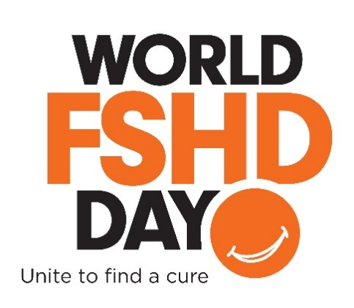

Every June 20th, people around the world join in activities to raise awareness for Facioscapulohumeral muscular dystrophy (FSHD) through World FSHD Day.

How to get involved

The Orange Slice Selfies campaign is our signature social media event to recognize World FSHD Day. Supporters post a photo of themselves to social media using an orange slice in place of their smile with the official hashtag #WorldFSHDDay. The campaign is designed to stand out on social media by combining the event’s official color, bright orange, with an eye-catching image representing a symptom experienced by many patients: the loss of the ability to smile. It is meant to start conversations! With your support, we have reached tens of millions of unique accounts on Twitter! See page 2 of this toolkit for a how-to.

Fundraise with Team FSHD Skyland Trail
In 2019, this team is participating in the Race Across America, the celebrated extreme cycling event in which cyclists race across the continental United States. The race falls on June 15-22. Anyone can support the team in honor of World FSHD Day, and even start their own fundraising team and invite friends and family to donate. Start your team ASAP so you have plenty of runway to raise a pile of donations. Team captain George Pollock has pledged to match the first $100,000 in gifts raised for Team FSHD Skyland Trail! To donate or start your own team visit their Team Page.

Other ways to support World FSHD Day
- Use the World FSHD Day logo as your social media avatar. You can download the logo here and upload it to your Facebook, Twitter, and Instagram accounts.
- Host a local event to celebrate the day. Invite your community to gather for a picnic, cocktail party, dance party, a viewing party see your local landmark lit up in orange (see below). Cut a bowlful of orange slices and take a group selfie! Share event announcements and photos on social media with #WorldFSHDDay.
- Ask your local Department of Public Works to Light the Night Orange. Is there a local landmark that would look great in orange? In Boston, MA, the famed Zakim Bridge is illuminated orange every June 20th in support of World FSHD Day. On page 3 is a template letter which you can use to craft your own request. Be sure to take photos of your orange landmark and post them on social media!
- Make it official: Ask your government to recognize World FSHD Day. Write to your city, state, and national governments with a request to proclaim June 20th as FSHD Awareness Day. See page 4 for a sample letter you can use.

Download the complete World FSHD Day toolkit so you have it at your fingertips.

Orange Slice Selfies

What is an Orange Slice Selfie and how do I do it?

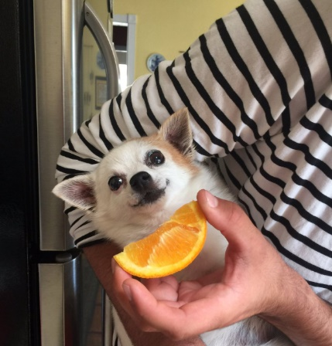
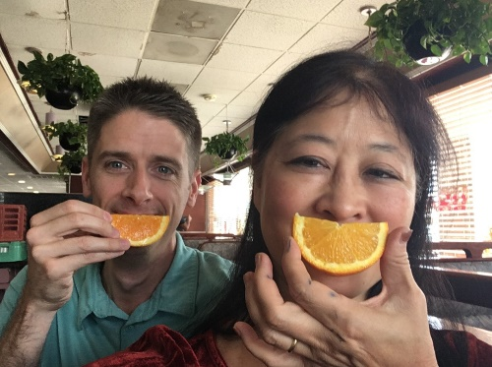
Slice, smile and snap! Taking part in our Orange Slice Selfie campaign is just that simple. Though each selfie includes the classic orange slice in place of a smile, what makes each one special is what you add to it. Grab your friends, family or pets and help us to bring awareness to FSHD and the FSH Society. Don’t forget to include #WorldFSHDDay in your post!

How do I share my Orange Slice Selfie on social media?

Now that you’ve got your Orange Slice Selfie photo ready, what is the best way to share your photo? We’ve included sample posts below to help you get the right words down. Don’t forget to tag your friends, the FSH Society (@FSHSociety on Twitter) and include our official hashtag, #WorldFSHDDay!

Facebook Suggestions
- Mark your calendars, June 20, 2018, is World FSHD Day! The day serves to gather individuals with FSHD, their families and supporters to raise awareness to the disease. To learn more, check out https://www.fshsociety.org/
- On June 20, I’m raising awareness for World FSHD Day by sharing an Orange Slice Selfie! Share a photo of your Orange Slice Selfie to show your support to #WorldFSHDDay & the @FSHSociety
- Today is #WorldFSHDDay! To unite our community & raise awareness to the disease, I’m sharing my Orange Slice Selfie. Join me by sharing yours or by making a donation to the @FSHSociety

Twitter Suggestions
- Mark your calendars, 6/20 is #WorldFSHDDay! Help us raise awareness to #FSHD & the @FSHSociety across the globe
- I’m wearing my Orange Slice Selfie this #WorldFSHDDay to raise awareness to #FSHD on 6/20. Share your smile w/ the @FSHSociety & make a donation today!
- Did you know #FSHD impacts 870K people worldwide? I’m sharing my Orange Slice Selfie on 6/20 to raise awareness for #WorldFSHDDay & ask you to do the same!
- Today is #WorldFSHDDay, put on your Orange Slice Selfie on & support the @FSHSociety!
- It’s #WorldFSHD Day! I’m sharing my Orange Slice Selfie to raise awareness & ask that you join me. To learn more & donate, check out https://bit.ly/2GHOx1s

Light the Night Orange sample letter

DATE
ADDRESS OF LOCAL PUBLIC WORKS OFFICE

Dear NAME,

My name is NAME and I serve as TITLE/MEMBER NAME of the FSH Society. I am writing to ask for a very special favor—to light up BUILDING orange this June 20th in honor of World FSHD Day, to recognize patients and families around the world who are affected by Facioscapulohumeral muscular dystrophy (FSHD).

FSHD is the most common form of muscular dystrophy, causing progressive skeletal muscle loss. It affects families in our community and almost a million people worldwide. There is no cure yet, but thanks to recent advances in research, we hope treatments will be developed soon. That’s why raising community awareness is so important. We want families living with FSHD to know they are not alone.

We would greatly appreciate for World FSHD Day to serve as an opportunity to spread awareness of FSHD, especially in CITY. To that end, we would like to ask that you to kindly arrange for LANDMARK to be lit orange on the night of June 20th, the official color for World FSHD Day.

If you can accommodate our request, we will promote it through a worldwide social media campaign, sharing images of LANDMARK in the World FSHD Day colors over Facebook and Twitter. This would be an incredibly powerful way to rally our community, with LANDMARK giving visibility to FSHD on a scale that we have never had before.

For more information, please visit https://www.fshsociety.org/. We hope that you will consider standing with FSHD patients, especially right here in CITY, by lighting BUILDING orange in their honor this June 20th.

Sincerely,
NAME

If a landmark will be lit orange, what now?
- Tell local media and social media influencers about it.
- Facebook Suggestions
  - On June 20, CITY is raising awareness for World FSHD Day by lighting BUILDING orange! Stop by at TIME to share a photo
  - Today is #WorldFSHDDay! To unite our community & raise awareness, BUILDING is lighting orange for those with FSHD. Stop by to share a photo for #WorldFSHDDay!
- Twitter Suggestions
  - BUILDING will be lighting up orange to recognize #WorldFSHDDay on 6/20! Stop by & share a photo to show support
  - DYK: #FSHD affects 870K people worldwide? BUILDING will be lighting the night orange on 6/20 to raise awareness for #WorldFSHDDay!
  - Today is #WorldFSHDDay! BUILDING is lighting the night orange in celebration, be sure to share a photo!
Ask for official proclamation – sample letter

DATE
HONORIFIC TITLE OF PUBLIC OFFICIAL
ADDRESS

Dear TITLE AND NAME,

On behalf of the FSH Society and our patients and families, I am writing to enlist your support in raising the visibility of Facioscapulohumeral muscular dystrophy (FSHD) by issuing a public proclamation this June 20th, which is World FSHD Day.

On this day, advocacy groups around the world will hold events and share messages on social media to bring awareness to this debilitating muscle disease. We ask STATE/CITY to join these voices by issuing a proclamation and recommending that the day be observed in an appropriate manner by the people. Your support will bring hope to our patients and families.

OPTIONAL: ADD PERSONAL NOTE, YOUR POSITION IN THE COMMUNITY OR AS A CONSTITUENT, YOUR CONNECTION TO FSHD.

FSHD affects nearly one million individuals worldwide and results in the progressive loss of all skeletal muscle. Scientific progress on this disease could not only lead to treatments for a cure but will also benefit a wide range of areas of medicine, from cancer and diabetes to muscle regeneration and repair.

ADD DESCRIPTION OF LOCAL/REGIONAL CONNECTIONS TO FSHD CLINICAL CARE AND RESEARCH; E.G. HOSPITALS THAT HAVE MUSCULAR DYSTROPHY CLINICS, RESEARCH LABS, BIOTECHS, AS WELL AS LOCAL FUNDRAISING EVENTS.

I look forward to working with you and your team to further these important efforts.

Sincerely,
NAME

If World FSHD Day is declared and observed in my community, how do I share this news?
- Tell local media and social media influencers about it.
- Facebook Suggestions
  - CITY/STATE/COUNTRY has proclaimed June 20th official FSHD Awareness Day in honor of all the families in our community who live with Facioscapulohumeral muscular dystrophy. Thank you [name of official] for your support! #WorldFSHDDay
  - Today is #WorldFSHDDay! To unite our community & raise awareness, CITY/STATE/COUNTRY has proclaimed June 20th the official FSHD Awareness Day!
- Twitter Suggestions
  - DYK #FSHD affects 870K people worldwide? CITY/STATE/COUNTRY has named 6/20 official FSHD Awareness Day #WorldFSHDDay!
  - Today is #WorldFSHDDay! Thanks to CITY/STATE/COUNTRY for making this official FSHD Awareness Day!

