Dr. Nikia Stinson’s equipment List
Most items are available on smile.amazon.com
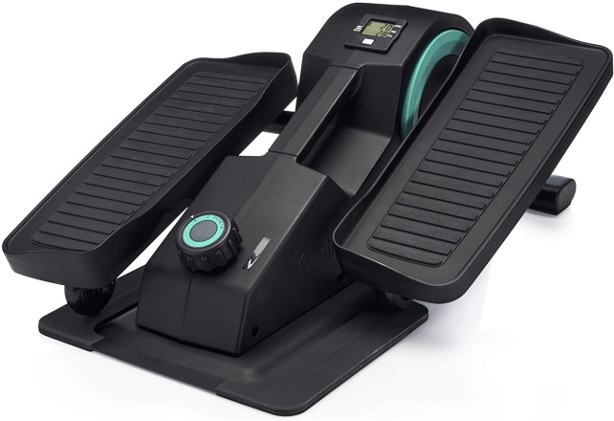
Cubii JR1 Seated Under Desk Elliptical Machine for Home Workout, Mini Elliptical, Desk Bike Pedal Exerciser, Whisper Quiet, Under Desk Pedal Exerciser
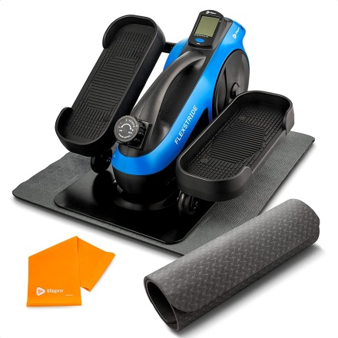
LifePro Under Desk Elliptical Trainer for Home & Office - Calf Leg Foot Pedal Exerciser - Seated Compact Elliptical Bike Machine

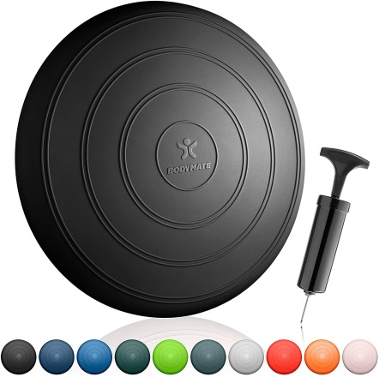
BODYMATE Comfort Wobble Cushion, Balance Cushion, Inflatable Stability disc, Balance Board, 13 inch
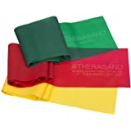
Theraband Latex, Yellow/Red/Green - Beginner Set
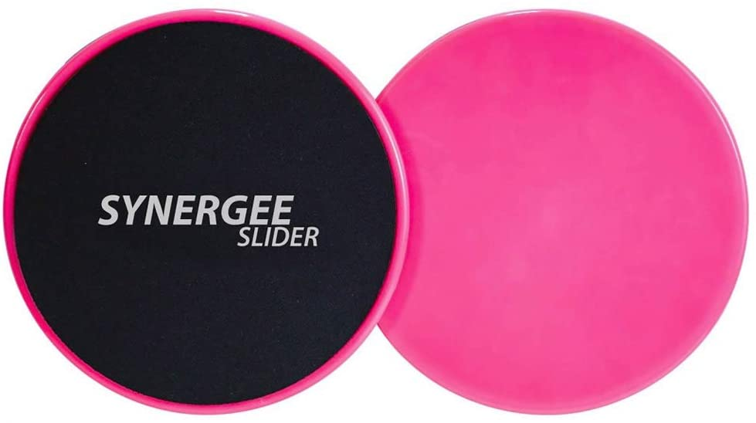
Synergee Core Sliders. Dual Sided Use on Carpet or Hardwood Floors.
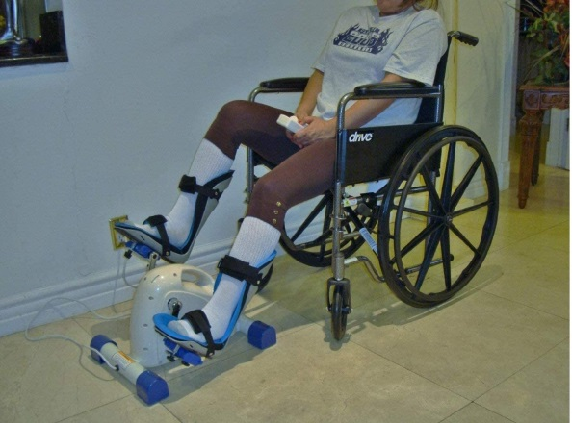
Modini-Z-40 Sago Foot Splints + Stroke Training Gloves + Motorized Exercise Cycle/Bike for The Handicapped & Disabled

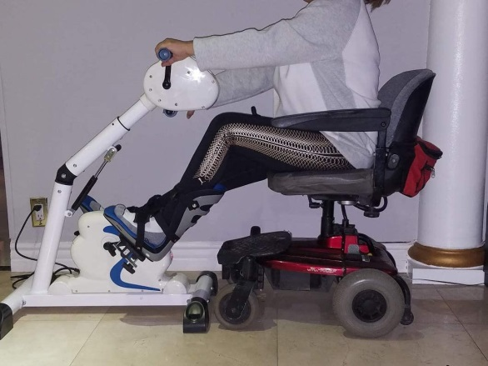
RJ-Mini Motorized Exercise Cycle/Bike + a Pair of Foot Supports and Gloves for Stroke Survivor- Handicapped & Disabled-SCI

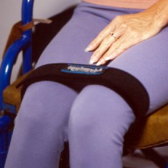
LS Leg Strap™ Sizes range from small to 3XL
https://www.advantagebag.com/products/ls-leg-strap
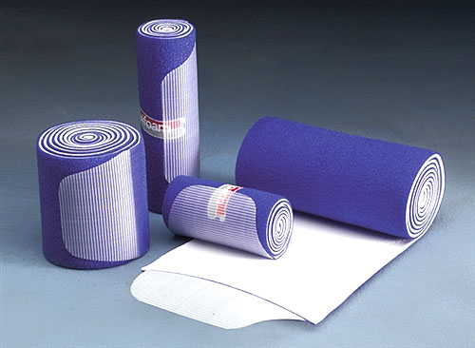

NuStim Wrap- sizes vary; can get the smallest one for use with feet
https://www.lymphedemaproducts.com/

